**Web Analytics tools**

Web analytics tools are software applications or services that help website owners and digital marketers track and analyze data related to website traffic, user behavior, and performance. These tools provide valuable insights into how visitors interact with a website, which can be used to optimize the site for better user experience and achieve specific business goals. Here are some popular web analytics tools:

**Google Analytics:** Google Analytics is one of the most widely used web analytics platforms. It offers a comprehensive set of features to track website traffic, user behavior, conversion rates, and more. It's a free tool that integrates well with other Google products.

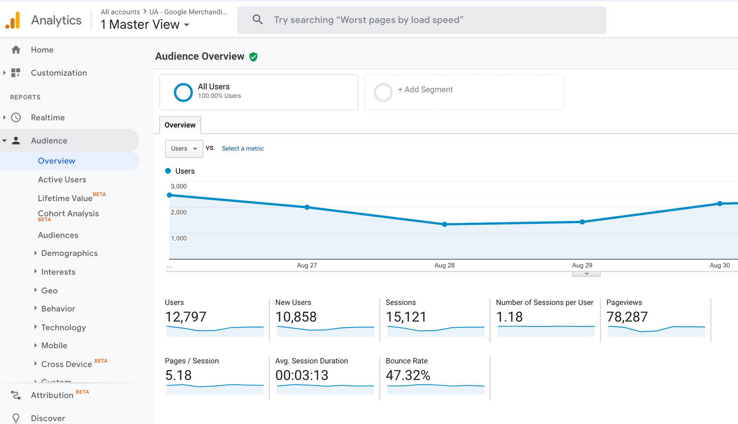

**Adobe Analytics:** Adobe Analytics is a robust analytics platform that provides in-depth insights into website and app performance. It is often used by large enterprises and offers advanced features for data analysis and reporting.

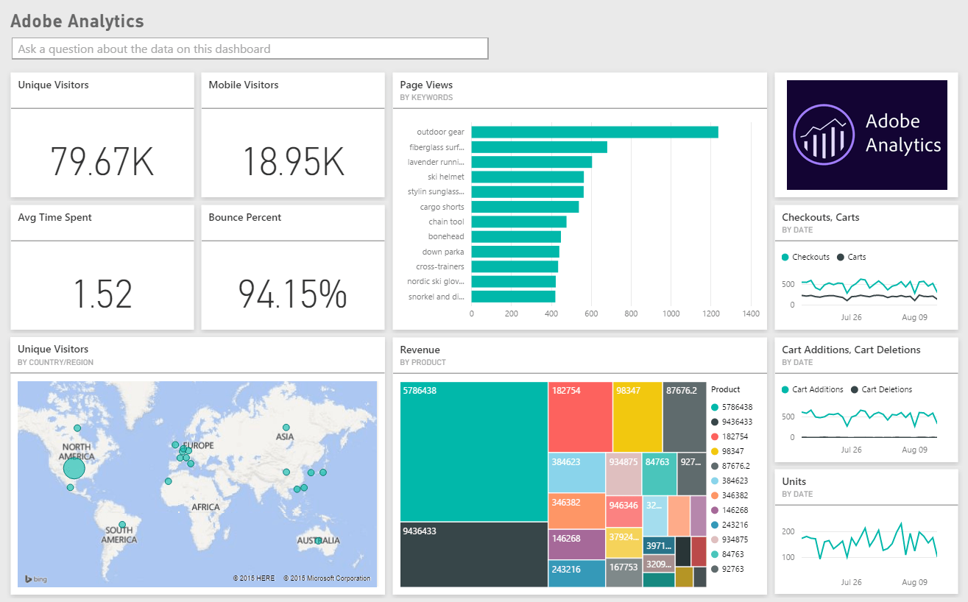

**Matomo (formerly Piwik):** Matomo is an open-source web analytics platform that provides privacy-focused analytics. It allows you to host your analytics data on your own servers, giving you full control over your data.

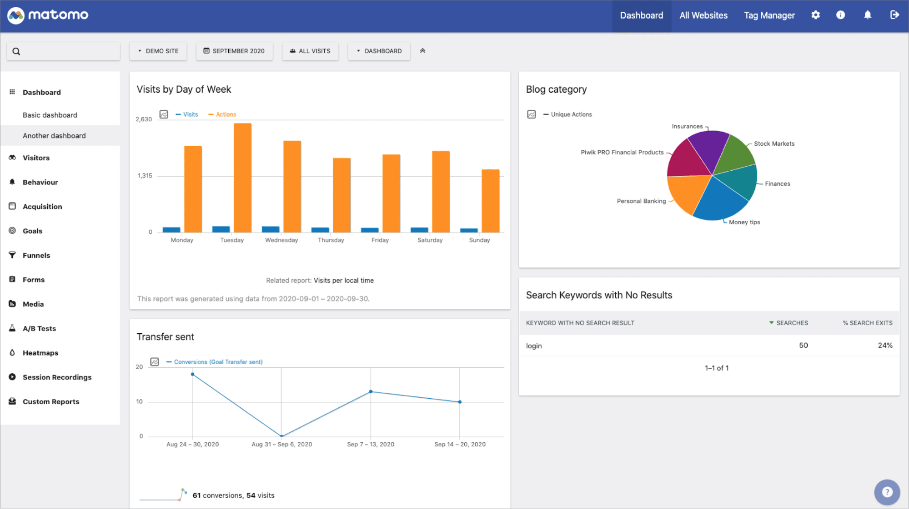

**Mixpanel:** Mixpanel is a user analytics tool that focuses on tracking user interactions within web and mobile applications. It helps businesses understand user behavior and engagement.

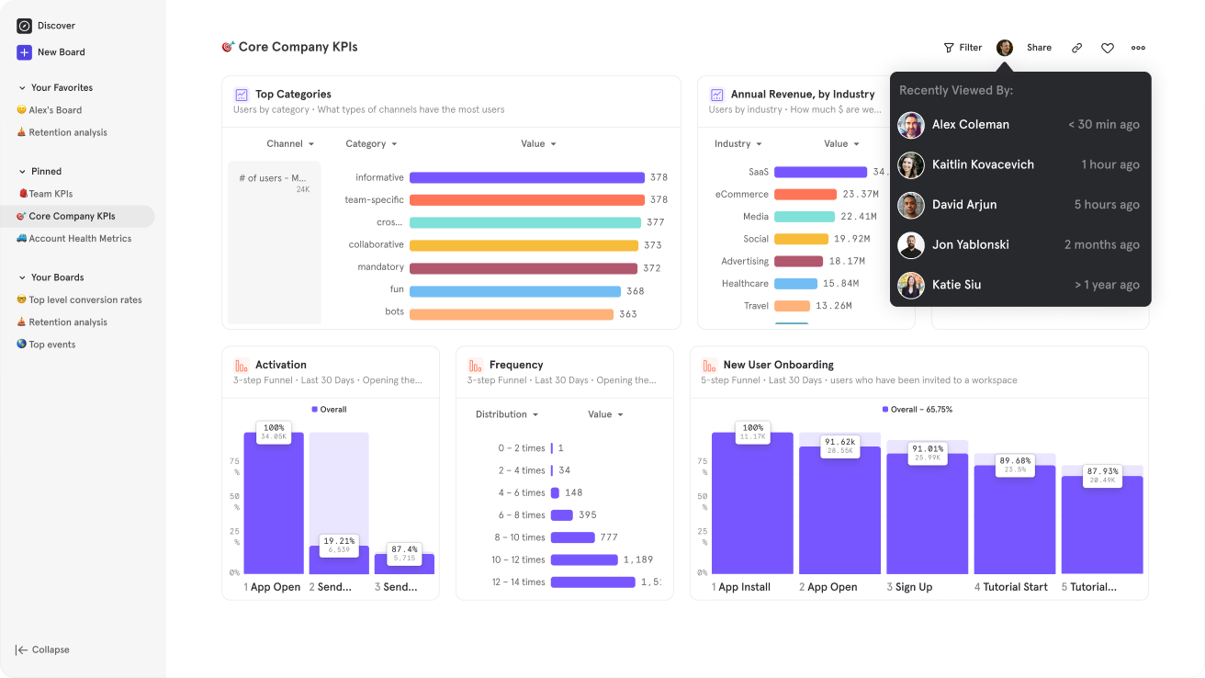

**Heap Analytics:** Heap Analytics simplifies event tracking by automatically capturing all user interactions on a website or app. Users can retroactively analyze data without pre-defining events.

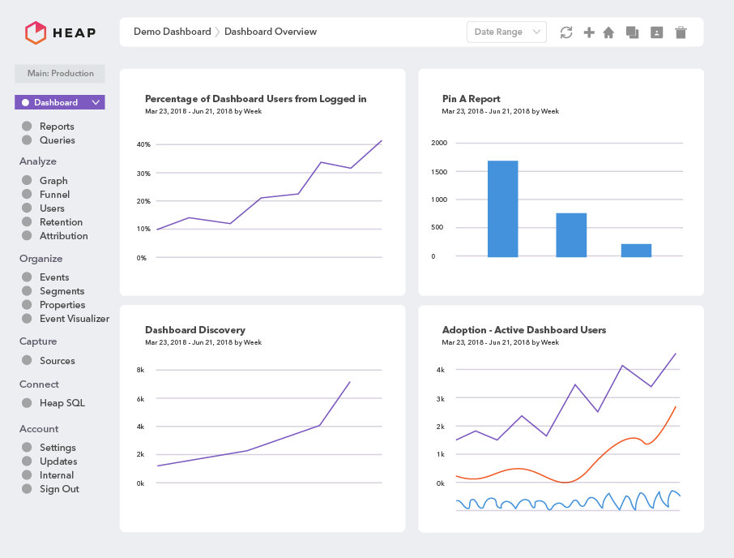

**Hotjar:** Hotjar combines website analytics with feedback tools like heatmaps, session recordings, and surveys. It helps you understand how users navigate and interact with your site.

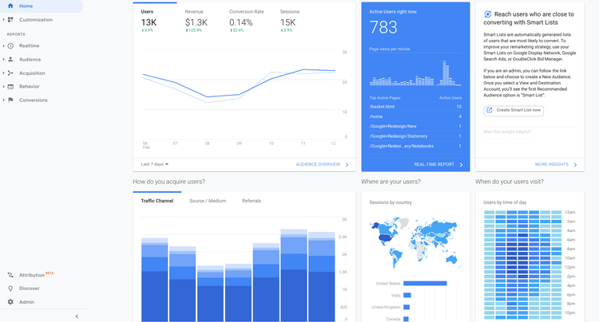

**Crazy Egg:** Crazy Egg offers heatmaps, scroll maps, and other visualization tools to understand user behavior. It also provides A/B testing and split testing capabilities.

**Woopra:** Woopra is a real-time customer analytics platform that provides insights into user journeys, segmentation, and behavior. It aims to help businesses understand the entire customer lifecycle.

**Clicky:** Clicky is a real-time web analytics tool that provides detailed information about website visitors, including their location, referrers, and behavior. It also offers heatmaps and uptime monitoring.

**Kissmetrics:** Kissmetrics focuses on customer engagement and retention analytics. It helps businesses track and analyze user behavior over time to improve customer lifetime value.

**StatCounter:** StatCounter offers basic website analytics with a focus on real-time visitor tracking. It's a simple and affordable option for smaller websites.

**Parse.ly:** Parse.ly is designed for content publishers and media companies. It provides insights into content performance, audience engagement, and reader behavior.

**Moz Pro:** Moz Pro includes web analytics as part of its broader suite of SEO and marketing tools. It helps businesses track rankings, inbound links, and website health.

**HubSpot Analytics:** HubSpot offers analytics tools as part of its marketing automation platform. It provides insights into website performance, lead generation, and customer interactions.

**SEMrush:** SEMrush is primarily known as an SEO and competitive research tool, but it also offers web analytics features to track website traffic, keywords, and backlinks.